COMSOL, Inc.  1 New England Executive Park, Suite 350  Burlington, MA 01803 USA  Phone: +1 781-273-3322  Web: www.comsol.com  Blog: www.comsol.com/blogs | Editor Contact  Valerio Marra, Technical Marketing Manager  valerio@comsol.com  Explore the Image Gallery featuring COMSOL 4.3b simulations: www.comsol.com/press/imagegallery.php
COMSOL Multiphysics 4.3b Offers Breakthrough Analysis Tools
Five new application-specific modules and additional features open new frontiers in multiphysics simulation. For a full description of the new capabilities, visit www.comsol.com/4.3b

BURLINGTON, MA (May 3, 2013) — COMSOL Inc., the leader in multiphysics simulation software, today announced the release of major new additions to the COMSOL simulation platform. The latest version of COMSOL Multiphysics, version 4.3b, introduces five new application-specific modules and expanded modeling and analysis tools. Release highlights are available at www.comsol.com/4.3b
New Application-Specific Modules
With the introduction of the five new modules, users in key application areas from major industries now have access to the new modeling and simulation tools offered by COMSOL.
- Multibody Dynamics Module – Provides users with the ability to analyze the assembly of rigid and flexible bodies. Transitional and rotational displacements, as well as locking, can be simulated for a variety of joint types, including prismatic, hinge, cylindrical, screw, planar, ball, slot, and reduced slot joints.
- Wave Optics Module – Allows users to analyze electromagnetic wave propagation in optically large structures, such as optical fibers and sensors, bidirectional couplers, plasmonic devices, metamaterials, laser beam propagation, and non-linear optical components.
- Molecular Flow Module – Offers the capability to simulate rarefied gas flow in complex CAD geometries of vacuum systems. This includes such applications as mass spectrometers, semiconductor processing, satellite technology, particle accelerators, shale gas exploration, and flow in nanoporous materials.
- Semiconductor Module – Enables the detailed analysis of semiconductor device operations at the fundamental physics level allowing for the modeling of PN junctions, bipolar transistors, MOSFETs, MESFETs, thyristors, and Schottky diodes.
- Electrochemistry Module – Tailored user interfaces are now available for electroanalysis, electrolysis, and electrodialysis. Typical applications include: glucose sensors, gas sensors, chlor-alkali electrolysis, desalination of seawater, waste water treatment, and control of electrochemical reactions in biomedical implants.
“With the introduction of these five new modules, COMSOL Multiphysics is able to offer a simulation package that is unique in the industry,” says Bjorn Sjodin, VP of Product Management at COMSOL. “There is no other software out there that offers the same accuracy across such a wide array of disciplines.”
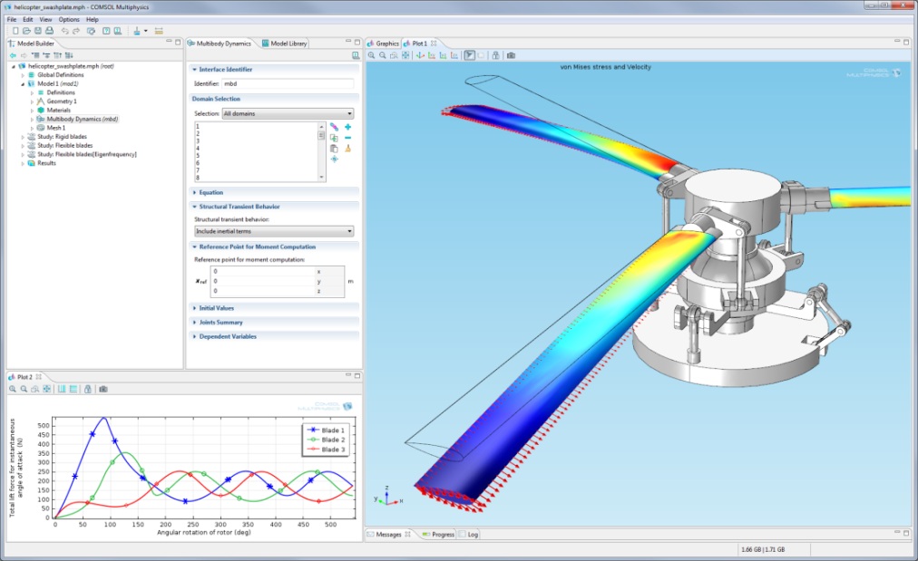
This model of the swashplate mechanism used to control helicopter rotor blades was developed using the Multibody Dynamics Module. Transient simulations with both rigid and flexible blade designs provide insight into useful performance metrics, such as blade deformation and lift force. Results show von Mises stress and deformation of the rotor blades.
New COMSOL Multiphysics Capabilities
The new features delivered with the COMSOL product suite include enhancements to CAD importing and geometry handling, meshing, physics, solvers, results, and productivity tools that offer increased usability and performance throughout the product development process. COMSOL Multiphysics 4.3b brings tremendous enhancements to features in existing modules, thus augmenting simulation speed and the capabilities of the entire product suite.
COMSOL continues to impact design processes by positively influencing the accuracy and immediacy of analysis results. “It is the mission of COMSOL to provide engineers and scientists with the right tools needed to design reliable and safe products,” says Ed Fontes, Chief Technology Officer at COMSOL.
- Geometry and Mesh – A new feature allows users to make quick what-if studies by taking a 2D geometry from the cross-section of a 3D geometry. A new curvilinear coordinate system tool makes it easier to define anisotropic materials in curved geometric shapes. Additionally, increased automated swept meshing capabilities allow for faster modeling.
- Interfacing and Productivity – The new One Window Interface with LiveLink™ for Inventor® allows users to work with COMSOL Multiphysics from within the Inventor® environment. New updates in LiveLink™ for Excel® allow the import of multiple models and export of material data from Excel® to COMSOL.
- Electrical – A new magnetics solver facilitates faster stationary and time-dependent magnetics simulations. A new electrical contact feature is added to the AC/DC Module; the electric current flowing between two surfaces now varies according to surface properties and contact pressure. The periodic structures for electromagnetic waves feature is now available in the RF Module.
- Mechanical – Bolt pre-tension and beam cross-section analysis can now be simulated in the Structural Mechanics Module. Cumulative damage for fatigue analysis with random amplitude loads is now available in the Fatigue Module. The Heat Transfer Module has been enhanced with multi-wavelength surface-to-surface heat radiation, heat transfer with phase change, and thermal contact features.
- Fluid – The new frozen rotor feature in the CFD Module efficiently solves for the pseudo-steady flow field in rotating machinery for laminar and turbulent flow. A new thin screen feature for thin permeable barriers allows the simulation of wire gauzes, grills, and perforated plates. Additionally, the SST turbulence model and a new CFD solver are now available.
- Chemical – The new thin impermeable barrier for mass transport feature allows users to represent thin walls as interior boundaries with a no-mass-flux condition on both sides.
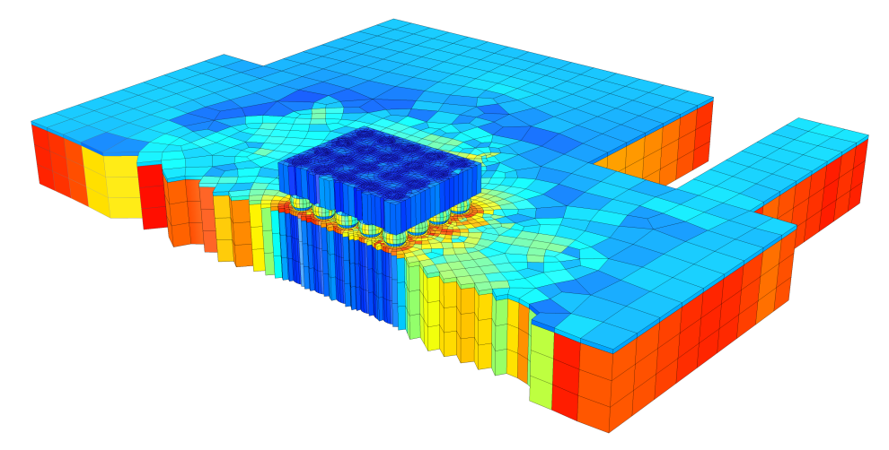
This model of a silicon chip soldered onto a circuit board was meshed using the enhanced swept meshing feature available in COMSOL Multiphysics. Element quality is shown where red represents a completely symmetric element.
In keeping with the modeling simplicity and effectiveness that users have come to expect from COMSOL, the new modules and features implemented in the simulation platform follow the same intuitive modeling process. “It’s extraordinary that users can experience the same workflow process no matter which simulation task or application they are working with,” says Bjorn Sjodin, “this unique approach allows users to adapt the COMSOL environment to address their specific needs and implement any solver or feature to their simulation to achieve the most useful results.” Since the modeling environment remains the same, both the new and existing modules can be combined and coupled to create simulations specifically designed by the user to address their unique simulation needs.
Software Download Now Available to Subscribing Users
COMSOL Multiphysics 4.3b is now available worldwide for download. On-subscription license holders of the RF Module, Structural Mechanics Module, or Microfluidics Module will receive the Wave Optics Module, Multibody Dynamics Module, or Molecular Flow Module, respectively, and for free. For more information about the new release, visit www.comsol.com/4.3b

About COMSOL
COMSOL provides simulation software for product design and research to technical enterprises, research labs, and universities through over 17 offices and a distributor network all over the world. Its flagship product, COMSOL Multiphysics®, is a software environment for modeling and simulating any physics-based system. A particular strength is its ability to account for coupled or multiphysics phenomena. Add-on products expand the simulation platform for electrical, mechanical, fluid flow, and chemical applications. Interfacing tools enable the integration of COMSOL Multiphysics simulation with all major technical computing and CAD tools on the CAE market.
~
COMSOL, COMSOL Multiphysics, Capture the Concept, COMSOL Desktop, and LiveLink are either registered trademarks or trademarks of COMSOL AB. All other trademarks are the property of their respective owners, and COMSOL AB and its subsidiaries and products are not affiliated with, endorsed by, sponsored by, or supported by those trademark owners. For a list of such trademark owners, see http://www.comsol.com/tm

